CAB301 Assignment 2

Empirical Comparison of Median Calculation Algorithms

Kathryn Dorge (n9701761)

and Luke Reynolds (n10083481)

Date submitted:

Table of Contents

1.0 Summary 2

2.0 Description of the Algorithm 2

2.1 Brute Force Median 2

2.2 Partitioning Median 3

3.0 Theoretical Analysis of the Algorithm 4

3.1 The algorithm’s basic operation 4

3.1.1 Brute Force Median Algorithm 4

3.1.2 Partition Median Algorithm 4

3.2 Average Case Efficiency 4

3.2.1 Brute Force Median Algorithm 4

3.2.2 Partition Median Algorithm 4

3.3 Best Case Efficiency 7

3.4 Worst Case Efficiency 7

3.5 Order of Growth 7

4.0 Methodology, Tools and Techniques 8

4.1 Programming Environment 8

4.2 Algorithm Implementation 8

4.3 Test Data and Execution of Experiments 8

5.0 Experimental Results 10

5.1 Functional Testing 10

5.1.1 Brute Force Median 10

5.1.2 Partitioning Median 10

5.2 Average-Case Number of Basic Operations 11

5.3 Average-Case Execution Time 11

6.0 References 12

7.0 Figures 13

8.0 Appendices 17

7.1 Appendix I: Code for Brute Force Median Algorithm Implementation 17

7.2 Appendix II: Code for Partitioning Median Algorithm Implementation 18

7.3 Appendix III: Code for Generating Random Test Data 20

7.4 Appendix IV: Code for Testing Brute Force Median Functionality 21

7.5 Appendix V: Code for Testing Partitioning Median Functionality 22

7.6 Appendix VI: Code for Basic Operation Count for Brute Force Median 23

7.7 Appendix VII: Code for Basic Operation Count for Partitioning Median 25

7.8 Appendix VIII: Code for Time Execution Test for Brute Force Median 27

7.9 Appendix IX: Code for Time Execution Test for Partitioning Median 28

# **Summary**

This report details the theoretical and empirical analysis of two possible median algorithms, with one taking a brute-force approach of locating the median value and another implementing a partitioning method similar to that of the quicksort algorithm. These algorithms where implementing within Java, utilising Oracles JDK, stable release 8. The empirical analysis will be conducted by first creating a simple counter which will count the number of times the basic operation is executed in both algorithms, and then by measuring the execution time of the implemented algorithms. Upon viewing the results ….

# **Description of the Algorithm**

The median in statistics is the value that separates the upper half of a set of data, a population, or a probability distribution, from the lower half or simply the middle value within a data set. This value remains extremely important within statistical analysis and probability theory due to the important of what it can represent for a data set or continuous probability distribution. Therefore, it has become of interest to implement a time efficient algorithm that is capable of locating the median value, even in situations where the data set remains unsorted. Thus, an efficient algorithm for locating the median value has been investigated, designed and compared.

## Brute Force Median

The Brute-Force Median algorithm, operates by systematically checking all possible elements for the solution, as the name implies. After checking each element, the value returned shall be the median value for the input data set. This is achieved by first calculating the position of the median, ***k***, if the data set were sorted then by utilising nested ***for*** loops to iterate over each element of the data set and compare it with every other element with ***i*** and ***j*** indexing the outer and inner loop respectively. During this time, two comparisons are conducted, one to check if the current element is larger than what it is being compared to, ***A[j] < A[i]***, if so then the variable ***numsmaller*** is incremented. The other to check if the current element is equal to what it is currently being compared to, ***A[j] = A[i]***, if so then ***numsequal*** is incremented. After the inner loop has finished executing, these two variables indicate the total number of data points smaller than and equal to the current element which can be used to deduce the current elements position index as being in-between the ***numsmaller + 1*** to ***(numsmaller + numequal)***. These values can therefore be compared to ***k*** to determine if the current element is the median, if so it returns a value otherwise it will continue to check the next element in the array with ***numsmaller*** and ***numequal*** are reinitialised to equal zero.

## Partitioning Median

Johnsonbaugh and Schaefer have proposed a version of the median algorithm that is built around the idea that locating the median within an unsorted data set is inherently a sorting problem, or more specifically a selection problem. As the median, as mentioned previously, is the middle value of a discrete data set, we need to only sort the array enough such that we can identify the central value, or the ***kth*** value. This is completed via utilising the underlying principles of the quicksort algorithm, the partitioning of the data set, producing a divide and conquer algorithm.

The implementation of this solution requires three methods, the Median method which handles the unique case of only one element in the data set existing, where it simply returns the value that element. For other data sets, calls the recursive method Select, passing the data set, the indexing value for the first element, the middle value of the data set, and the indexing value for the last element in the data set. This Select method recursively calls itself until the partitioning method returns the desired middle value is returned. It should be noted that upon each call, the algorithm is reduced such that the points of interest lay between ***l*** and ***h***. The work of partially sorting the array is completed by the partitioning method, which is the procedure that is heavily utilised in the Quicksort Algorithm. It first selects a pivot as the first element from the portion of the data set in interest, it then swaps all elements, such that values smaller than the pivot lay on the left-hand side and values greater than the pivot lay on the right-hand side of the pivot. The index value of the pivot is then returned to the selection algorithm for it to be determined if the pivot selected is the median.

# **Theoretical Analysis of the Algorithm**

This section of the report details the average case theoretical analysis of each algorithm along with the choice of basic operation and the order of growth.

## The algorithm’s basic operation

Each algorithm’s basic operation will be utilised in the theoretical analysis of the average case efficiency which will be outline below.

### **3.1.1 Brute Force Median Algorithm**

Upon conducting the basic operation of choice was the comparison ***A[j] < A[i]***, and was utilised in the average case efficiency analysis, as seen in figure …. This operation was selected as the basic operation due to the fact that this comparison has the greatest impact on the execution time of the algorithm, due to the fact that this operation is performed the greatest number of times and being the dominant operation in the algorithm. This comparison is executed within the nested ***for*** loop and is performed upon each iteration of the inner loop.

However, the other comparison present, ***A[j] = A[i]***, ***numsaller < k*** and, ***k ≤ (numsaller + numequal)***, within the algorithm will also affect the execution time by a variable amount. However, for this analysis it was assumed that the ***numsaller < k*** and, ***k ≤ (numsaller + numequal)*** comparison is less dominant and the ***A[j] = A[i]*** comparison being simplified to a two way comparison with ***A[j] < A[i]*** as per Levitin’s simplifying notion … REFERENCE …. when calculating the order of growth. Thus, they were not considered during the average case efficiency analysis, while a more detailed analysis shall take into account these comparisons.

### **3.1.2 Partition Median Algorithm**

When conducting the theoretical analysis of the partitioning median algorithm, the basic operation of interest chosen is the comparison of ***A[j] < pivotval*** contained within the partitioning method, as seen in figure …. This statement was selected due to it being a crucial element in not only the partitioning method, but the median algorithm as well. This is due to the fact that the median methods complexity relies on that of the selection method and in turn the partitioning method, with this comparison being the dominant operation. This operation is executed within a ***for*** loop that iterates over an array between the indexes ***l + 1*** and ***h*** as specified by parameters to the partitioning function.

It should be noted that the swapping of elements completed within the partitioning algorithm will have an impact on the execution time. However, during execution of the algorithm, it is believed that this operation will have negligible impact on its order of growth, as it is assumed that the comparison to provide sufficient estimation of the average case efficiency. Thus, the analysis conducted within this report does not consider the swapping of elements operation.

### **3.1.3 Commonality of Basic Operation**

The basic operation selection for each algorithm was based off of what was the dominant operation in each algorithm. While also as these are solutions to a selection problem, the basic operations are chosen to reflect this with the dominant operation being a key comparison. Thus, it can be stated that between the brute-force median algorithm and the partitioning median algorithm, the basic operations of choice reflect their nature of selection problems and represent the dominant operation. Also because of this commonality, the analysis’ derived from these basic operations allows for a valid comparison between the two algorithms.

## Problem Size

The choice of problem size for both algorithms is the input data size as this will affect the number of times the basic operation is executed and in turn the time execution.

## Average Case Efficiency

### **3.2.1 Brute Force Median Algorithm**

### **3.2.2 Partition Median Algorithm**

Upon execution of the partitioning median algorithm with the input data set being unknown and randomised, the execution of the basic operation is unknown due the divide and conquer nature of the algorithm. Therefore, the average case efficiency analysis is conducted, with assumptions made for an average data set.

First, the ***Partition*** method’s complexity must be analysed which shall be denoted as . The basic operation within this method is executed upon each iteration of the ***for*** loop:

Where indicates the length of the data set being analysed, including the pivot, that the method iterates over. Thus, for simplicity this value shall be represented as , where is the size of the data set within the partitioning method,

This produces an order of growth for the partitioning algorithm of ***n***, for the rest of this analysis, this shall be utilised to represent the complexity of the partitioning method. This is due to the fact that the ***- 1*** component of the complexity is inconsequential to the execution time of the partitioning median algorithm,

Now before analysing the recursive ***Select*** method, of which will be denoted as , some assumptions must first be made, including that upon each iteration the data set size is to decrease by one quarter in size. This was assumed due to the fact that if the data set where to decrease by one half, then the median would be found on the first iteration, or near the first iteration.

To simplify calculations, let

This recursive function can therefore be simplified to,

This function represents the average complexity of the selection method assuming that it does not return early from the function and completes ***k – 1*** recursive calls. Therefore, this will not produce an accurate analysis of the average case efficiency of the selection method. Therefore, it is then assumed that the median can appear in any element and has equal probability to do so,

Where ***p*** is the probability that the median exists within the data set, which will always be equal to one. It should also be noted that after each iteration of the ***for*** loop, the data set that is being iterated over decreases in size by assumedly , therefore, after each iteration it becomes more likely that the median is selected within the array,

Where ***j*** represents the number of recursive calls made by the selection method. Applying the expected value formula, the expected complexity can be determined to be,

This can be simplified to,

To simplify this, the summation of geometric progressions is used, as some of these summation elements produce a geometric series,

Now, as , ,

Now investigating the ***Median*** method, it simply calls the select function after handling the unique case of only one element existing within the array. Therefore, it can be stated that the average case efficiency of the Median algorithm is equal to that of the ***Selection*** method,

## Order of Growth

# **Methodology, Tools and Techniques**

## Programming Environment

The algorithms and experiments were developed using a combination of Java Integrated Development Environments (IDE). IntelliJ IDEA Community was used for the implementation of the brute force median algorithm and Eclipse was used for the implementation of the partition median algorithm. Both IDE’s are completely free and open source development environments.

The experiments were carried out using a custom-built gaming pc running windows 10 x64. The specs for the testing machine are: i7-960 (3.2Ghz) Processor, 8GB DDR3 RAM, NVidia GeForce GTX760 2Gb graphics card, 128Gb SSD, 2Tb WD-Black HDD, Dual 27” Full HD Asus monitors. The integrated Java random number generator was used to produce the test data for analysis and the built-in Java time module was used for measuring execution times.

Graphs of the experimental results were produced using a java library called JFreeChart. The library is passed all variables directly through the java application upon completion of the tests to create the graphs with all results being stored in .csv files.

## Algorithm Implementation

For the algorithm to function it is required that it is passed an array of integers. A function was built to accommodate this requirement which simply creates an array of set size and fills it with random integer values as seen in Appendix III. The algorithms were developed in separate java classes to keep the functions separate and organised. The four algorithms seen in Figure 1 to 4 were implemented in java and can be seen in Appendix 1 & 2.

## Test Data and Execution of Experiments

To confirm the functionality of the algorithms implemented a test class was built to test the functions against a hard-coded set of integers as seen in Appendix 4 & 5. The test classes ensure that the functions maintain accurate response to certain cases such as being passed an empty array or an unsorted array.

To count the number of basic operations performed by each algorithm to complete a search a counter was added to increment on each iteration of the algorithm. At this point another class was developed to test the algorithms and count the average number of basic operations for each array size ranging from one thousand to half a million.

Measuring the time required to complete an execution of each algorithm was very similar to counting the operations in that a variable had to be declared - prior to executing the algorithm – to store the current time in milliseconds using the built-in java time module into a long variable. Once the algorithm completes the search the execution time can then be extrapolated by subtracting the current time from the start time. This was again tested against the same number of arrays and sizes to conclude the average execution times.

# **Experimental Results**

## Functional Testing

### **Brute Force Median**

### **5.1.2 Partitioning Median**

Before commencing the empirical analysis of the partitioning algorithm, the functionality must first be verified. This was accomplished by utilising Java JUnit testing suite to provide the median method with a range of hard coded test cases. The code associated with these test cases are contained within Appendix …. These test cases include what is considered normal data set conditions, and any extreme cases that may arise during a programs execution. It should be noted, that both even and odd data set lengths where tested, as this solution to the selection median problem will select the upper value when two middle values are present, which occur in even sized data sets. In order to verify that the correct value was returned, the ***assertEquals*** assertion, which is a part of the JUnit test frame work, was utilised and given the expected value.

The first normal data set provided to the Median method is:

***{ 1, 2, 3, 4, 5, 6, 7, 8 }***

Where an expected value of ***5*** was produced thus, it can be stated that for a sorted array, the median value returned was the desired value. It also confirmed that within an even set of numbers, the upper middle value is returned from the median function. Another formal data set implemented is:

***{ 9, 1, 2, 8, 3, 4, 4, 1, 9, 2 }***

The expected value for the median was ***4***, which was returned. Therefore, upon passing this test it can be stated that for unsorted arrays, the median was accurately calculated. Another hardcoded test case was:

***{ -5, 9, 11, -1, -4, 6, 7, 60, 11, 99, 1 }***

This test case checks to determine if the algorithm continues to function as expected when negative values are contained within the data set. As the function produced the expected result of ***7*** then it can be stated that in this circumstance, the algorithm performed as expected. To further investigate the functionality of the algorithm under even and odd sized data sets, one addition value was added to this data set, such that it became:

***{ -5, 9, 11, -1, -4, 6, 7, 60, 11, 99, 1, -99 }***

This formed an even sized data set, where there would be two median values. As this method is to functionally return the upper of the two values, the expected result is ***7***, which was received. Finally, the last hard coded data set is utilised:

***{ 0, 1, 2, 3, 80, 7, 90, 4 }***

This test case was utilised to determine if the median algorithm accurately returned values if there are large variations within the initial data set, of which it performed as expected returning a ***4***. Therefore, it can now be confidently stated that this algorithm is capable of returning the correct median value under normal circumstances.

The next test cases purpose is to determine if the algorithm is to perform as expected under circumstances that may arise due to any errors. This includes passing the median function two data sets that only contained one value:

***{ 1 } and { 5 }***

As expected, these returned the one element that existed within the array, and thus it can be stated that is one element is passed to the median algorithm, it can correctly identify the median. Other cases tested where when only three numbers within the data set existed:

***{ 1, 1, 1, 1, 1, 5, 5, 5, 5, 5, 4 }***

The median function was able to return the expected median value of ***4*** was returned from the function. While also, a data set containing only one value was also tested:

***{ 1, 1, 1, 1, 1, 1, 1, 1, 1, 1, 1 }***

And again, the median value returned was as expected, thus it can be stated that for these circumstances the median function will be capable of producing correct results. It should also be stated that for the purposes of testing, a data set of zero elements was passed to the median, where it was expected that an exception was thrown, as was the case.

## Average-Case Number of Basic Operations

## Average-Case Execution Time

# **References**

1. <http://www.jfree.org/jfreechart/>
2. <https://en.wikipedia.org/wiki/Brute-force_search>

# **Figures**

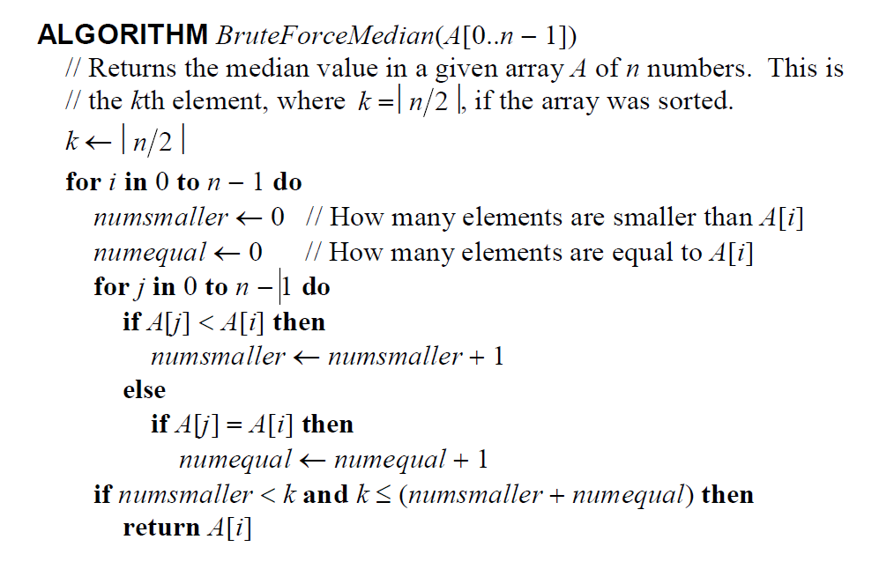

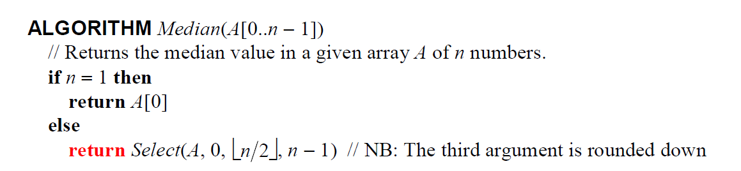

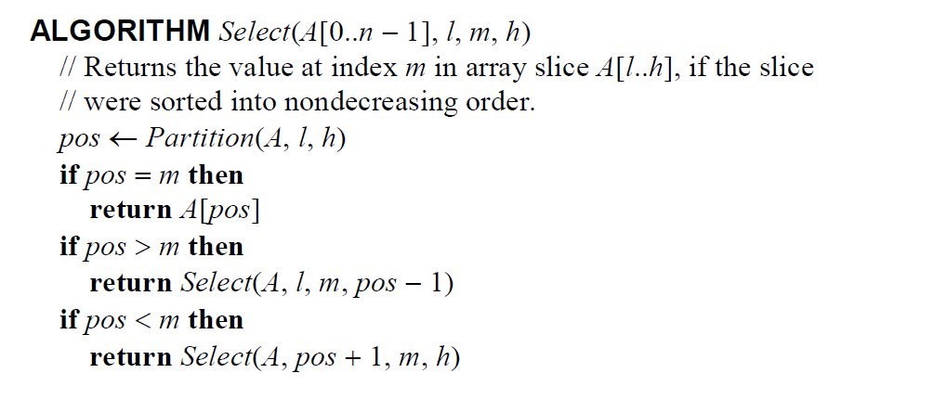

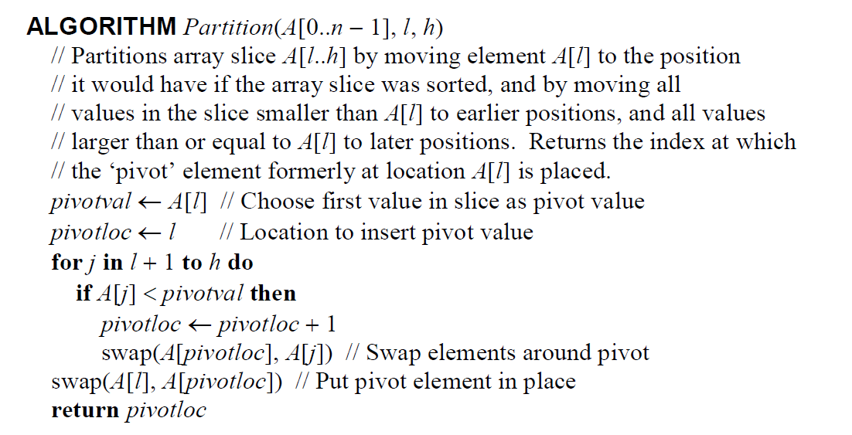

# **Appendices**

## Appendix I: Code for Brute Force Median Algorithm Implementation

*/**  
 * Returns the median value in a given array A of n numbers.  
 \** ***@param*** *array  
 \** ***@return*** *\*/*public static int BruteForceMedian(int[] array) throws Exception{  
 if (array.length != 0){  
 int k = (int)Math.*ceil*((array.length+1)/2);  
 for (int i = 0; i < array.length; i++){  
 int smaller = 0;  
 int equal = 0;  
 for (int j = 0; j < array.length; j++){  
 *operCounter*++;  
 if (array[j] < array[i]){  
 smaller += 1;  
 } else if (array[j] == array[i]){  
 equal += 1;  
 }  
 }  
 if (smaller < k && k <= (smaller + equal)){  
 return array[i];  
 }  
 }  
 return k;  
 } else {  
 throw new Exception();  
 }  
  
}

Contained in the BruteForceAlgorithm class

## 7.2 Appendix II: Code for Partitioning Median Algorithm Implementation

*/**  
 * Returns the median value given to the array, if an event number  
 * exists it returns the element to the right of the middle  
 \** ***@param*** *array  
 \** ***@return*** *\*/* public static int Median(int[] array)  
 {  
 if ( array.length == 1 )  
 return array[0];  
 else  
 return *Select*( array, 0, (int)Math.*floor*( array.length / 2 ), array.length - 1 );  
 }

Contained in the PartitionAlgorithm class

*/**  
 * Returns the value at index m in array slice A[l...h], if the slice  
 * where sorted into nondecreasing order  
 \** ***@param*** *array  
 \** ***@param*** *low  
 \** ***@param*** *mid  
 \** ***@param*** *high  
 \** ***@return*** *\*/*public static int Select(int[] array, int low, int mid, int high)  
{  
 int pos = *Partition*( array, low, high );  
   
 if ( pos == mid )  
 return array[pos];  
 if ( pos > mid )  
 return *Select*( array, low, mid, pos - 1 );  
 if ( pos < mid )  
 return *Select*( array, pos + 1, mid, high );  
   
 return 0;  
}

*/**  
 * Partitions array slice A[l...h] by moving element A[l] to the position  
 * it would have if the array slice was sorted, and by moving all values in  
 * the slice smaller than A[l] to earlier positions, and all values larger  
 * than or equal to A[l] to later positions.   
 \** ***@param*** *array  
 \** ***@param*** *low  
 \** ***@param*** *high  
 \** ***@return*** *Returns the index at which the pivot element formerly at location  
 * A[l] is placed  
 */* public static int Partition(int[] array, int low, int high)  
 {  
 int pivotval = array[low];  
 int pivotloc = low;  
   
 for ( int j = low + 1; j <= high; j++ )  
 {   
 if ( array[j] < pivotval )  
 {  
 pivotloc++;  
   
 // swap elements  
 int tempVal = array[pivotloc];  
 array[pivotloc] = array[j];  
 array[j] = tempVal;  
 }  
 }  
   
int tempVal = array[low];  
array[low] = array[pivotloc]; // swap elements around pivot  
array[pivotloc] = tempVal; // put pivot element in place  
   
 return pivotloc;  
 }

Contained in the PartitionAlgorithm class

## 7.3 Appendix III: Code for Generating Random Test Data

*/**  
 * Uses the random number generator to generate an array of int [size] with random numbers in each index  
 \** ***@param*** *size  
 \** ***@return*** *\*/*public static int[] generateRandomArray( int size )  
{  
 Random randomNumberGenerator = new Random();  
  
 int[] randArray = new int[size];  
  
 for ( int i = 0; i < size; i++ )  
 {  
 randArray[i] = randomNumberGenerator.nextInt();  
 }  
  
 return randArray;  
}

Contained in the Main class

## 7.4 Appendix IV: Code for Testing Brute Force Median Functionality

@Test  
public void testBasicCase() throws Exception{  
 *assertEquals*(4, BruteForceAlgorithm.*BruteForceMedian*(new int[]{1, 3, 4, 6, 7}));  
 *assertEquals*(3, BruteForceAlgorithm.*BruteForceMedian*(new int[]{1, 3, 4, 6}));  
 *assertEquals*(2, BruteForceAlgorithm.*BruteForceMedian*(new int[]{1, 2, 3, 4, 7, 9}));  
 *assertEquals*(0, BruteForceAlgorithm.*BruteForceMedian*(new int[]{0, 0, 0, 0, 0, 0, 0}));  
}

@Test  
public void testEdgeCases() throws Exception{  
 *assertEquals*(1, BruteForceAlgorithm.*BruteForceMedian*(new int[]{1}));  
 *assertEquals*(8, BruteForceAlgorithm.*BruteForceMedian*(new int[]{8}));  
 *assertEquals*(1, BruteForceAlgorithm.*BruteForceMedian*(new int[]{1, 1, 1, 1, 1, 1, 1, 1, 1, 1}));  
 *assertEquals*(4, BruteForceAlgorithm.*BruteForceMedian*(new int[]{1, 1, 1, 1, 8, 8, 8, 8, 4}));  
}

@Test (expected = Exception.class)  
public void testEmptyCase() throws Exception{  
 BruteForceAlgorithm.*BruteForceMedian*(new int[]{});  
}

@Test  
public void testOperationCount() throws Exception{  
 BruteForceAlgorithm.*operCounter* = 0;  
 BruteForceAlgorithm.*BruteForceMedian*(new int[]{1, 2, 3, 4, 5});  
 *assertEquals*(15, BruteForceAlgorithm.*operCounter*);  
}

@Test  
public void testAverageCount() throws Exception{  
 BruteForceAlgorithm.*operCounter* = 0;  
 int[][] arrays = new int[][]{new int[]{1, 3, 4, 6, 7}, new int[]{1, 3, 4, 6}, new int[]{1, 3, 4, 4, 7, 9}, new int[]{0, 0, 0, 0, 0, 0, 0}};  
 long[] basicOperationCounter = new long[arrays.length];  
 int index = 0;  
 for (int [] arr : arrays){  
 BruteForceAlgorithm.*BruteForceMedian*(arr);  
 basicOperationCounter[index] = BruteForceAlgorithm.*operCounter*;  
 index++;  
 }  
 *assertEquals*(31, Main.*calculateAverage*(basicOperationCounter));  
}

Contained in the TestBruteForceAlgorithm class

## 7.5 Appendix V: Code for Testing Partitioning Median Functionality

@Test  
public void testSimpleCases()   
{  
 *assertEquals*( 5, PartitionAlgorithm.*Median*( new int[] { 1, 2, 3, 4, 5, 6, 7, 8 } ) );  
 *assertEquals*( 4, PartitionAlgorithm.*Median*( new int[] { 9, 1, 2, 8, 3, 4, 4, 1, 9, 2 } ) );  
 *assertEquals*( 7, PartitionAlgorithm.*Median*( new int[] { -5, 9, 11, -1, -4, 6, 7, 60, 11, 99, 1 } ) );  
 *assertEquals*( 7, PartitionAlgorithm.*Median*( new int[] { -5, 9, 11, -1, -4, 6, 7, 60, 11, 99, 1, -99 } ) );  
 *assertEquals*( 4, PartitionAlgorithm.*Median*( new int[] { 0, 1, 2, 3, 80, 7, 90, 4 } ) );  
}

@Test  
public void testEdgeCases()  
{  
 *assertEquals*( 1, PartitionAlgorithm.*Median*( new int[] { 1 } ) );  
 *assertEquals*( 5, PartitionAlgorithm.*Median*( new int[] { 5 } ) );  
   
 *assertEquals*( 4, PartitionAlgorithm.*Median*( new int[] { 1, 1, 1, 1, 1, 5, 5, 5, 5, 5, 4 } ) );  
 *assertEquals*( 1, PartitionAlgorithm.*Median*( new int[] { 1, 1, 1, 1, 1, 1, 1, 1, 1, 1, 1 } ) );  
}

@Test (expected = Exception.class)  
public void testEmptyArray() throws Exception  
{  
 PartitionAlgorithm.*Median*( new int[] {} );  
}

@Test  
public void testOperationCount(){  
 PartitionAlgorithm.*MedianBasicOperationCount*(new int[]{1, 2, 3, 4, 5});  
 *assertEquals*(9, PartitionAlgorithm.*basicCounter*);  
}

Contained in the TestPartitionMedian class

## 7.6 Appendix VI: Code for Basic Operation Count for Brute Force Median

public static long *operCounter* = 0;

...

*/**  
* Returns the median value in a given array A of n numbers.  
\** ***@param*** *array  
\** ***@return****\*/*public static int BruteForceMedian(int[] array) throws Exception{  
 ...  
 for (int i = 0; i < array.length; i++){  
 ...  
 for (int j = 0; j < array.length; j++){  
 *operCounter*++;  
 ...  
 }  
 ...  
 return array[i];  
 ...  
 }  
 return k;  
 ...  
}

...

Contained in the BruteForceAlgorithm class

*/**  
* Tests run on the brute force median algorithm to produce experimental results for analysis  
\** ***@throws*** *Exception  
*/*public static void bruteForceTests() throws Exception {  
 ...  
 long avgOperations;  
 long[] basicOperationCounter;  
 ...  
  
 for (int arraySize = 1000; arraySize < 502000; arraySize += 5000){  
 basicOperationCounter = new long[testsPerSize];  
 ...  
 for ( int i = 0; i < testsPerSize; i++ ) {  
 ...  
 BruteForceAlgorithm.*operCounter* = 0;  
 BruteForceAlgorithm.*BruteForceMedian*(randArray);  
 basicOperationCounter[i] = BruteForceAlgorithm.*operCounter*;  
  
 data.put(arraySize, new Long[]{basicOperationCounter[i], execTimeCounter[i]});  
 }  
 avgOperations = *calculateAverage*(basicOperationCounter);  
 ...  
 *operationsDataSet*.addValue( avgOperations, "Brute Force", Integer.*toString*(arraySize));  
 }  
 *saveData*(data, "bruteForceData.csv");  
}

Contained in the Main class

## 7.7 Appendix VII: Code for Basic Operation Count for Partitioning Median

public static long *basicCounter* = 0;

...

*/**  
 * Partitions array slice A[l...h] by moving element A[l] to the position  
 * it would have if the array slice was sorted, and by moving all values in  
 * the slice smaller than A[l] to earlier positions, and all values larger  
 * than or equal to A[l] to later positions.  
 *  
 \** ***@param*** *array  
 \** ***@param*** *low  
 \** ***@param*** *high  
 \** ***@return*** *Returns the index at which the pivot element formerly at location  
 * A[l] is placed  
 */*public static int PartitionBasicOperationsCount(int[] array, int low, int high) {  
 ...  
 for (int j = low + 1; j <= high; j++) {  
 *basicCounter*++;  
 ...  
 }  
 ...  
 return pivotloc;  
}

...

Contained in the PartitionAlgorithm class

*/**  
 * Tests run on partition median algorithm to produce experimental results for analysis  
 \** ***@throws*** *Exception  
 */*public static void partitionTests() throws IOException {  
 ...  
 long[] basicOperationCounter;  
  
 ...

for (int size = 1000; size < 502000; size+= 5000){  
 ...  
 basicOperationCounter = new long[numArraysTested];  
 for ( int i = 0; i < numTests; i++ )  
 {  
 ...  
 PartitionAlgorithm.*basicCounter* = 0;  
 PartitionAlgorithm.*MedianBasicOperationCount*( randArray );  
 basicOperationCounter[i] = PartitionAlgorithm.*basicCounter*;  
 ...  
 fl.write( basicOperationCounter[i] + ",");  
 }

// calculate average  
 for ( int j = 0; j < numTests; j++ )  
 {  
 ...  
 basicOperationCounter[j] /= numTests;  
 *operationsDataSet*.addValue(basicOperationCounter[j], "Partition", Integer.*toString*(size));  
 }  
 }  
 ...  
}  
...

Contained in the Main class

## 7.8 Appendix VIII: Code for Time Execution Test for Brute Force Median

*/**  
 * Tests run on the brute force median algorithm to produce experimental results for analysis  
 \** ***@throws*** *Exception  
 */*public static void bruteForceTests() throws Exception {  
 ...  
 long startTime;  
 long avgExecTime;  
 long[] execTimeCounter;  
 ...  
  
 for (int arraySize = 1000; arraySize < 502000; arraySize += 5000){  
 execTimeCounter = new long[testsPerSize];  
 for ( int i = 0; i < testsPerSize; i++ ) {  
 ...  
 startTime = System.*currentTimeMillis*();  
 BruteForceAlgorithm.*BruteForceMedian*(randArray);  
 execTimeCounter[i] = System.*currentTimeMillis*() - startTime;  
 ...  
 data.put(arraySize, new Long[]{basicOperationCounter[i], execTimeCounter[i]});  
 }  
 avgExecTime = *calculateAverage*(execTimeCounter);  
 *execTimeDataSet*.addValue(avgExecTime, "Brute Force", Integer.*toString*(arraySize));  
 ...  
 }  
 *saveData*(data, "bruteForceData.csv");  
}

Contained in the Main class

## 7.9 Appendix IX: Code for Time Execution Test for Partitioning Median

*/**  
 * Tests run on partition median algorithm to produce experimental results for analysis  
 \** ***@throws*** *Exception  
 */*public static void partitionTests() throws IOException {  
 ...  
 long[] executionTimeCounter;  
 ...  
 for (int size = 1000; size < 502000; size+= 5000){  
 ...  
 executionTimeCounter = new long[numArraysTested];  
 for ( int i = 0; i < numTests; i++ )  
 {  
 ...  
 startTime = System.*currentTimeMillis*();  
 PartitionAlgorithm.*MedianBasicOperationCount*( randArray );  
 executionTimeCounter[i] = System.*currentTimeMillis*() - startTime;  
 ...  
 fl.write(executionTimeCounter[i] + "\n");  
 }  
  
 // calculate average  
 for ( int j = 0; j < numTests; j++ )  
 {  
 ...  
 executionTimeCounter[j] /= numTests;  
 *execTimeDataSet*.addValue(executionTimeCounter[j], "Partition", Integer.*toString*(size));  
 }  
 }  
 ...  
}

Contained in the Main class